


Reporting Framework for
Resolution of Public Complaints and Implementation of Citizens’ Service Delivery Charter Indicators under Performance Contracting for the Financial Year 2026/2027

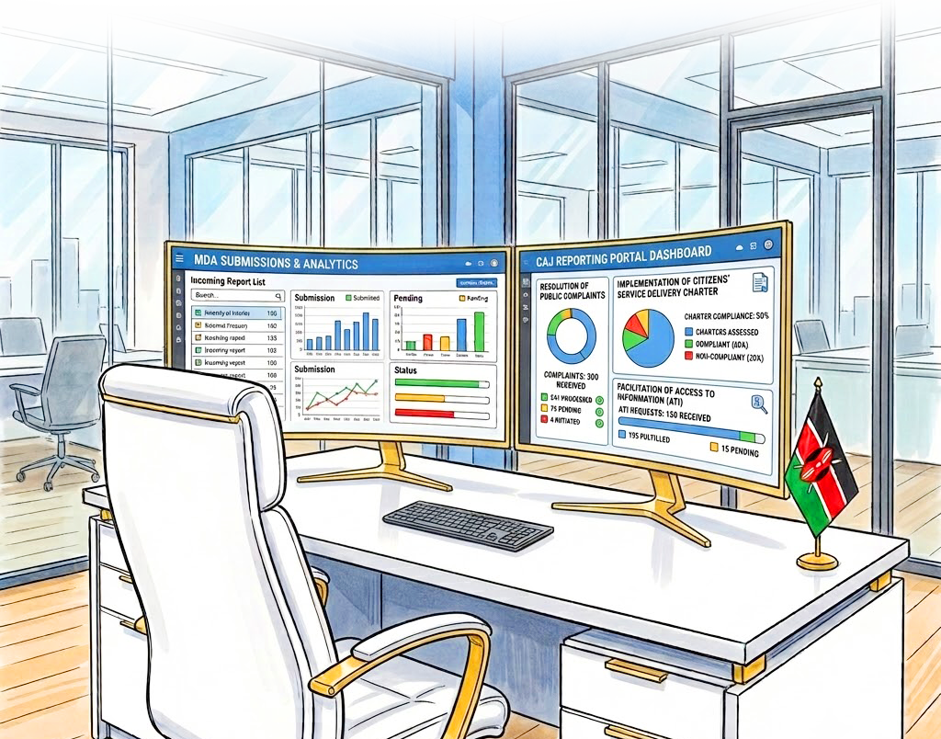
16TH EDITION



16th Edition Reporting Framework for

Resolution of Public Complaints and Implementation of Citizens’ Service Delivery Charter Indicators under Performance Contracting for the Financial Year 2026/2027

VISION
A society that upholds Administrative Justice and Access to Information.

MISSION
To enforce Administrative Justice and Access to Information in Kenya through complaints resolution and public education for efficient and effective service delivery.

CORE VALUES

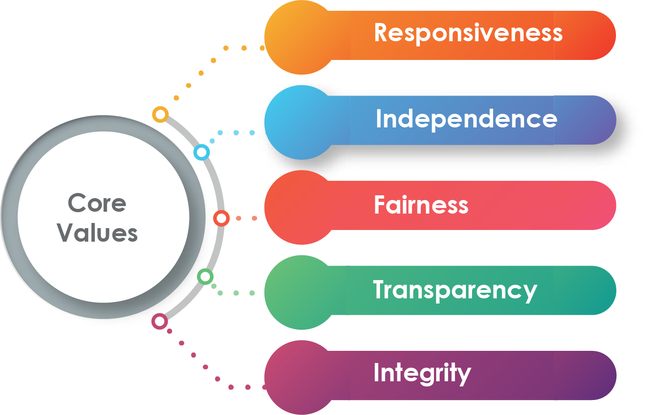

Table of Contents
SECTION 1: PREFACE 1
1.1 Establishment of the Commission on Administrative Justice 1
1.2 Functions of the Commission 1
SECTION 2: ROLE OF THE COMMISSION IN THE PERFORMANCE CONTRACTING FRAMEWORK 3
SECTION 3: PURPOSE, SCOPE, AND DEFINITIONS 4
3.1 Purpose 4
3.2 Scope 4
3.3 Definitions 4
4.1 Submission of Quarterly Reports 7
4.2 Mode of Reporting 7
4.3 Late Submission of Reports 7
4.4 Feedback 7
4.5 Nil Returns 7
4.6 Compliance Certificate 7
4.7 Timelines for Resolution of Complaints 7
4.8 Timelines for Processing Information Requests 8
SECTION 5: EVALUATION CRITERIA 9
5.1 Resolution of Public Complaints Indicator 9
5.1.1 Quarterly Scoring 9
5.1.2 Evaluation Requirements 9
5.2 Implementation of Citizens' Service Delivery Charter Indicator 10
5.2.1 Evaluation Parameters 10
5.2.2 Parameter 1: Completeness of the Compliance Report (15%) 10
5.2.3 Parameter 2: Institutional Compliance Rate (40%) 11
5.2.4 Parameter 3: Adequacy of Variance Explanations and Corrective/Preventive Actions (5%) 11
CHAPTER 6: PENALTIES AND APPEALS 13
6.1 Penalties 13
6.2 Appeals 13
ANNEXES: 15

SECTION 1: PREFACE

1.1 Establishment of the Commission on Administrative Justice
The Commission on Administrative Justice (CAJ) is established under Article 59(4) of the Constitution of Kenya through the Commission on Administrative Justice Act, 2011 (Cap 102A of the Laws of Kenya).

The Commission is mandated to enforce administrative justice in the public sector and oversight the implementation of the right to information under Article 35 of the Constitution and the Access to Information Act, 2016. It enforces administrative justice by addressing maladministration through effective complaints handling and alternative dispute resolution; promoting good governance and efficient public service delivery by enforcing the right to fair administrative action; and by investigating abuse of power, manifest injustice and unlawful, oppressive, unfair or unresponsive official conduct. The Commission equally plays a critical role in enforcing the right of access to information, including receiving and determining complaints arising from violations of the right to access information.

In addition, the Commission has a constitutional mandate to safeguard public interest by promoting constitutionalism, securing the observance of democratic values and principles, and protecting the sovereignty of the people of Kenya.

1.2 Functions of the Commission
The functions of the Commission as provided for in Section 8 of the CAJ Act, 2011 include:
- Investigate any conduct in state affairs, or any act or omission in public administration by any State organ, State or public officer in National and County Governments that is alleged or suspected to be prejudicial or improper or is likely to result in any impropriety or prejudice;
- Investigate complaints of abuse of power, unfair treatment, manifest injustice or unlawful, oppressive, unfair or unresponsive official conduct within the public sector;
- Report to the National Assembly bi-annually on the complaints investigated under paragraphs (a) and (b), and the remedial action taken thereon;
- Inquire into allegations of maladministration, delay, administrative injustice, discourtesy, incompetence, misbehavior, inefficiency or ineptitude within the public service;
- Facilitate the setting up of, and build complaint handling capacity in the sector of public service, public offices and state organs;
- Work with different public institutions to promote alternative dispute resolution methods in the resolution of complaints relating to public administration;
- Recommend compensation or other appropriate remedies against persons or bodies to which this Act applies;
- Provide advisory opinions or proposals on improvement of public administration, including review of legislation, codes of conduct, processes and procedures; and
- Promote public awareness of policies and administrative procedures on matters relating to administrative justice.

In addition, the Commission has the following functions under the Access to Information Act:
- To investigate violations of the provisions of the Act;
- To receive reports from public entities with respect to implementation of the Act and evaluating the use and disclosure of information;
- To facilitate public awareness and develop programs on the right to access information;
- To promote right of access to information in public entities;
- To monitor state compliance with international obligations related to the right to access information;
- To hear and determine complaints and review decisions arising from violations of the right to access information; and
- To perform such other function as the Commission may consider necessary for the promotion of access to information.

SECTION 2: ROLE OF THE COMMISSION IN THE PERFORMANCE CONTRACTING FRAMEWORK
The Commission is a specialized agency under the performance contracting framework in Kenya whereby it oversees implementation of the Resolution of Public Complaints and the Citizens' Service Delivery Charter Indicators. To this end, the Commission facilitates the setting up of and strengthening capacities in complaint handling, access to information, and service delivery charter in the public sector to enhance efficiency in service delivery.



SECTION 3: PURPOSE, SCOPE, AND DEFINITIONS

3.1 Purpose
This Framework provides guidelines to public institutions regarding compliance with the Resolution of Public Complaints and Implementation of Citizens' Service Delivery Charter Indicators under the 23rd cycle National Performance Contracting guidelines.

3.2 Scope
This Framework applies to public institutions at the national and county levels.

3.3 Definitions
The following definitions apply throughout this Framework:
Action Taken | The intervention measure(s) taken by an institution to either resolve a complaint or process a request for information.
Audit | Independent examination of data, statements, records, operations and performance of a public institution for purposes of compliance with the indicator.
Citation Register | A reference document kept by the Commission for citing unresponsive and malfeasant public officers and institutions.
Citizens' Service Delivery Charter (CSDC) | A document prepared as a public commitment by an institution that clearly states the services it provides, the standards, cost and timelines within which those services will be delivered, the rights and responsibilities of service users, and the mechanisms available for feedback, complaints, and redress when standards are not met.
Commitment | A specific service standard or obligation undertaken by a public institution in its Citizens' Service Delivery Charter and against which compliance is measured.
Complainant | A person, group of people or organization lodging a complaint.
Complaint | An expression of dissatisfaction by a person, group, or organization about an unsatisfactory or unacceptable service, situation, including an act of commission or omission by a public officer or institution.
Complaint Channel | A medium through which a complaint is transmitted to its intended audience or organization, such as letter, email, telephone, and so on.
Complaint Handling Procedure | The steps taken by an institution to process and resolve a complaint.
Complaint Issue | A brief description of the complaint.
Compliance | The extent to which a public institution has delivered services in accordance with the commitments and standards set out in its Citizens' Service Delivery Charter.
Conformity | The extent to which the services, processes and practices of an institution are consistent with and meet the requirements, standards and commitments specified in the Citizens' Service Delivery Charter.
Corrective Action | Action taken to eliminate or mitigate the causes of existing problems, complaint or non-compliance with Charter commitments in order to prevent recurrence.
Information | Includes all records held by a public institution regardless of the form in which it is stored, its source or the date of production.
Information Access Officer | Any officer of a public institution designated under Section 7 of the Access to Information Act, 2016.
Monitoring | Continuous assessment of service delivery through review of quarterly reports and compliance audits, supervisory visits and spot checks undertaken by the Commission.
New Complaint | A complaint received within 30 days before the end of the reporting period, that remains unresolved.
On-going Complaint | A complaint received within the reporting period but has not been resolved.
Pending Complaint | Unresolved complaint brought forward from a previous reporting period.
Public Institution | Any institution of the National or County Government, Constitutional or Statutory Commission, Tribunal, Bodies or Committee, Parastatal or State Corporation, and any other institution which is funded directly from the consolidated fund or receives money appropriated by Parliament.
Reactive Disclosure | Release of information held by a public institution upon request.
Remedial Action | Specific steps, solutions or corrective measures taken to resolve a complaint, address the harm caused and prevent the recurrence of similar grievances.
Reporting Period | Timelines set for submission of reports as per this Framework.
Request for Information Processing Procedure | The steps taken by an institution to process a request for information.
Resolved Complaint | A complaint to which remedial action has been taken.
Review | The re-examination of a complaint, decision, or outcome to determine whether it was handled correctly, fairly, and in accordance with applicable laws, policies, or procedures.
Root Cause of a Complaint | The underlying cause(s) of a complaint.
Service Standard | A clearly defined and measurable level of performance that an institution commits to achieve in delivering its services.
Variance | The difference between the committed service standard and the actual achievement recorded by a public institution during the reporting period.

SECTION 4: MONITORING AND REPORTING

4.1 Submission of Quarterly Reports
Every public institution is required to submit a quarterly report on resolution of public complaints and implementation of citizens' service delivery charters to the Commission, within fifteen (15) calendar days following the end of each quarter, as per the templates provided in the annexures (marked Table I to Table IV).

4.2 Mode of Reporting
Reports are to be submitted via e-mail in PDF format. The email subject should indicate the name of the institution, the quarter and the financial year — e.g., Quarter One Report for Ministry of Trade for the FY 2026/27. The dedicated e-mail address for submission is: certificationpc@ombudsman.go.ke .

4.3 Late Submission of Reports
Any report submitted beyond the due date shall attract a penalty of up to a maximum of fifteen (15) percent on a pro-rata basis. However, this is restricted to fifteen calendar days after the deadline, beyond which the report will be inadmissible.

4.4 Feedback
The Commission will provide feedback on the reports submitted within 45 days of the submission deadline.

4.5 Nil Returns
Public institutions are expected to submit reports on all complaints received and resolved. However, in the event a public institution submits a report with nil returns on complaints handled directly, the Commission may apply other parameters and/or conduct an audit to verify the validity of the report.

4.6 Compliance Certificate
The Commission shall, at the end of the financial year, issue a compliance certificate for resolution of public complaints and a compliance report of citizens' service delivery commitments and standards to a public institution that has complied with the requirements stipulated in this Framework.

4.7 Timelines for Resolution of Complaints
Public institutions are required to resolve complaints within thirty (30) days from the date of receipt, in line with the CAJ Regulations and applicable policy guidelines. Where a review is instituted, it shall be finalized within thirty (30) days from the date received.

4.8 Timelines for Processing Information Requests
Requests for information shall be processed within 21 days from the date of receipt, or 48 hours where it concerns the life or liberty of a person. In the event the information requested is not within the custody of the public institution, the request shall be transferred to the relevant institution within five (5) days from the date of receipt and the Applicant/Requester informed accordingly.

N.B: Requests for further clarifications or engagements on the reporting tools should be made through the email certificationpc@ombudsman.go.ke or telephone number 0202270045.

SECTION 5: EVALUATION CRITERIA

5.1 Resolution of Public Complaints Indicator
The Resolution of Public Complaints Indicator measures the extent to which public institutions receive, process and resolve complaints from members of the public, as well as handle requests for information, in a timely, fair and effective manner.

The Commission's evaluation under this indicator is based on the quarterly reports submitted by public institutions using the templates provided in Annexes I, II, III of this Framework (Tables 1A, 1B, 2A and 2B).

5.1.1 Quarterly Scoring
S/NO. | ITEM | SCORE
1 | A report on complaints received and processed (See annexed Tables 1A & 1B) | 70%
2 | A report on requests for information received and processed (See annexed Tables 2A and 2B) | 30%
 | TOTAL | 100%

5.1.2 Evaluation Requirements
- Public institutions are required to provide details for ALL ongoing complaints, indicating challenges and actions taken towards resolution (See annexed Table 1C)
- Public institutions MUST capture a statistical summary of complaints and ATI (Tables 1A, 1B, 2A and 2B) in Table 3 labelled as Annex III.
- Public institutions with nil returns under Tables 1B and 2B will be evaluated using other parameters including but not limited to the customer satisfaction index or compliance indexes on resolution and ATI.
- Each state department in a ministry is required to submit reports separately. The yearly scores for the ministry will be the average of the submissions by the state departments and the ministry.
- The Commission will undertake compliance audits on public institutions based on complaints received, engagements with the Commission and reports submitted.

5.2 Implementation of Citizens' Service Delivery Charter Indicator
The evaluation criteria under this Framework apply exclusively to Sub-indicator iii of the Citizens' Service Delivery Charter Indicator. It carries a weight of sixty percent (60%) of the overall Citizens' Service Delivery Charter Indicator score under the Performance Contracting Framework for FY 2026/2027.
The Commission's evaluation is based on the quarterly compliance reports submitted by public institutions using the template provided in Annex IV of this Framework (Annex II of the PC Guidelines).

5.2.1 Evaluation Parameters
Public institutions will be evaluated under Sub-indicator iii based on three (3) parameters as set out below. Each parameter is assigned a specific weight that contributes to the overall 60% score for this Sub-indicator:

NO. | PARAMETER | WEIGHT
 | Completeness of the compliance report.  NB: In Q1, the institution must submit a soft copy of the Citizens' Service Delivery Charter as evidence. | 15%
 | Institutional % compliance rate (services delivered within Charter standards) | 40%
 | Adequacy of variance explanations and corrective/preventive actions documented | 5%
 | TOTAL — SUB-INDICATOR III | 60%

5.2.2 Parameter 1: Completeness of the Compliance Report (15%)
This parameter assesses whether the compliance report submitted by an institution is complete and contains all the required information as provided in the prescribed template (Annex IV of this Framework). Specifically, the Commission will verify that:
- The compliance report captures all the services/commitments as set out in the institution's Citizens' Service Delivery Charter and the corresponding target/service standards for each service as stipulated in the Charter.
- In Quarter 1 of each financial year, every institution is required to submit a copy of its Citizens' Service Delivery Charter alongside the compliance report as supporting evidence, to enable the Commission to cross-check and verify that all services/commitments and targets/service standards have been accurately and fully captured in the report.
- From Quarter 2 onwards, submission of the Charter is NOT required unless the institution has revised it, in which case the revised Charter must accompany the compliance report for the quarter in which the revision takes effect.
Where an institution does not offer a particular service during a quarter, it shall indicate this clearly in the achievement column and provide a brief explanation. Leaving cells blank without explanation shall be treated as an incomplete report.

5.2.3 Parameter 2: Institutional Compliance Rate (40%)
This parameter assesses the institution's actual level of conformity with the service delivery commitments and standards set out in its Citizens' Service Delivery Charter. The institution shall calculate the percentage compliance for each service/commitment as follows:
- Where a service is delivered within or equal to the set standard, the percentage compliance for that service shall be 100%; and
- Where a service is delivered outside the set standard, the percentage compliance shall be calculated as:
Institutional % Compliance = [100 − ((Achievement − Set Standard) ÷ Set Standard) × 100] %
Example: Where the set standard is 30 days and the service was delivered in 20 days, the percentage compliance is 100% (delivered within standard). Where the service was delivered in 40 days, the percentage compliance is: [100 − ((40 − 30) ÷ 30) × 100] = [100 − 33.3] = 66.7%.

5.2.4 Parameter 3: Adequacy of Variance Explanations and Corrective/Preventive Actions (5%)
This parameter assesses the quality, specificity and adequacy of the institution's response to instances of non-compliance recorded in the compliance report. Where a service has not been delivered within the set standard during the quarter, the institution is expected to provide a clear, specific and genuine explanation of the root cause(s) of the variance and document specific, actionable and measurable corrective or preventive actions taken or proposed.
The Commission will monitor trends in variance explanations and corrective actions across quarters. Where the same variance is recorded for the same service over three (3) or more consecutive quarters without demonstrable corrective action or measurable improvement, the Commission may escalate the matter as provided for under the Penalties section of this Framework.

SECTION 6: PENALTIES AND APPEALS

6.1 Penalties
The Commission may institute sanctions against public institutions that do not comply with provisions of this Framework as follows:
- A penalty of 5 percentage points will be imposed on reports submitted in the incorrect formats.
- A deduction of up to a maximum of 15 percentage points on a pro-rata basis for late submission of reports.
- Withhold compliance certificate at the end of the financial year if a public institution fails to:
  - Respond to CAJ enquiries;
  - Implement CAJ recommendations;
  - Honour summons or notice to show cause from CAJ;
  - Comply with the reporting guidelines; or
  - Submit false or misleading quarterly reports.
- Report non-responsive public institutions/officers to Parliament as per Section 42 of the CAJ Act, 2011.
- Take legal action as provided for under Section 52 of the CAJ Act and Sections 18 and 28 of the Access to Information Act.

6.2 Appeals
An institution may appeal against either of the following decisions made by the Commission:
- Award of the Quarterly Score: An institution dissatisfied with a quarterly score shall submit its appeal within fifteen (15) calendar days of receiving the quarterly feedback from the Commission.
- Denial of the Compliance Certificate: Upon conclusion of the annual evaluation, the Commission will issue a notification to all institutions that has not been awarded a compliance certificate. An institution dissatisfied with this decision shall submit its appeal within fifteen (15) calendar days of receiving the notification.
In both cases, the appeals shall clearly set out the grounds upon which the institution disputes the score awarded and shall be accompanied by supporting evidence where applicable. Appeals submitted outside the stipulated timeline or without supporting justification shall not be considered. The Commission will communicate its decision on the appeal within thirty (30) days of receipt.
The appeal shall be submitted in writing and addressed to the Commission Secretary/CEO.

ANNEXES:
ANNEX I: COMPLAINTS REPORTING TEMPLATES
TABLE 1A. COMPLAINTS AGAINST PUBLIC INSTITUTION LODGED WITH THE COMMISSION ON ADMINISTRATIVE JUSTICE
Name of Institution:
Quarter Ending:
CAJ Ref. No. | Date Received | Complaint Channel | Name of Complainant | Complaint Issue | Action Taken | Root Cause | Corrective Action | Status |  |  | Pending from Previous Quarters
 |  |  |  |  |  |  |  | Resolved (include Date resolved) | On-going | New | Resolved (include Date resolved) | On-going

TABLE 1B. COMPLAINTS LODGED DIRECTLY WITH THE INSTITUTION
Name of Institution:
Quarter Ending: Financial Year:
S/No. | Date Received | Complaint Channel | Name of Complainant | Complaint Issue | Action Taken | Root Cause | Corrective Action | Status |  |  | Pending from Previous Quarters
 |  |  |  |  |  |  |  | Resolved (include Date resolved) | On-going | New | Resolved | On-going

Table 1C: On-going Complaints
S/No | On-going complaints (Complaint Issue) | Brief narrative on challenges and actions taken towards resolution

ANNEX II: REQUESTS FOR INFORMATION REPORTING TEMPLATES
TABLE 2A: REQUESTS FOR INFORMATION THROUGH CAJ
Name of Institution: |  |  |  |  |  |  |  |  |  |  | Pending from previous Quarters
Quarter Ending: Financial Year: |  |  |  |  |  |  |  |  |  |  | Pending from previous Quarters
CAJ/REF. No. | Date Received | Name Of Applicant | Gender Of the Applicant | Requisition Channel | Type Of Information Requested | *Decision  (Action Taken) | Reason For Decision | Date Of Communicating Decision | Number Of Days Taken to Process the Request | Fees Imposed  (If Any)  (Ksh.) | *Decision  (Action Taken)

TABLE 2B: REQUESTS FOR INFORMATION RECEIVED DIRECTLY
Name of Institution: |  |  |  |  |  |  |  |  |  |  | Pending from previous Quarters
Quarter Ending: Financial Year: |  |  |  |  |  |  |  |  |  |  | Pending from previous Quarters
S/No. | Date Received | Name Of Applicant | Gender Of the Applicant | Requisition Channel | Type Of Information Requested | *Decision  (Action Taken) | Reason For Decision | Date Of Communicating Decision | Number Of Days Taken to Process the Request | Fees Imposed  (If Any)  (Ksh.) | *Decision  (Action Taken)

Note: Ensure that reactive disclosure of information is in compliance with the ATI Act.

*Decision on request for information may fall under the following categories:
- Granted request: refers to a request processed and information provided.
- Transferred request: refers to a request that has been referred to another public institution that is the custodian of the requested information (to be transferred within five (5) days from the date of receipt).
- Declined request: refers to request not granted on account of Section 6 of the ATI Act on exemptions.
- Pending request: refers to request for access to information which is still in process.
- Deferred request: refers to a request for access to information has been kept in abeyance on account of the Applicant/Requester failing to meet their obligations under the Act or further action is required from the applicant.

ANNEX III: TABLE 3: QUARTERLY STATISTICAL SUMMARY

Name of Institution:
Quarter Ending: Financial Year:
COMPLAINTS QUARTERLY STATISTICAL SUMMARY(I)
Number of Complaints | Complaints Received from the Commission (TABLE 1A) | Complaints Lodged Directly with the Institution (TABLE 1B)
Total Number Resolved
Total Number On-going
Total Number New
Total Number Received
Average Time for Resolution of Complaints (In Days)
Average Stipulated Timeline on your Citizen Service Delivery Charter for Resolution of Complaints (In Days)
CUSTOMER SATISFACTION SURVEY | Year | Index (%)
Latest Customer Satisfaction Index
QUARTERLY STATISTICAL SUMMARY OF REQUESTS FOR INFORMATION(II)
 | Requests for Information from CAJ (Table 2A) | Requests for Information (Table 2B)
Total Number Of Requests Granted
Total Number of Requests Transferred
Total Number of Requests Declined
Total Number of Pending Requests
Total Number of Requests Deferred
Total number of requests regarding correction of personal information
Total Number of Requests Received
Average Number of Days Taken to Process the Requests
Total Amount of Fees Collected from Requests (Ksh)
Total Number of Full-Time Staff Devoted to Processing Requests
Total Cost for Processing Requests (Ksh)
Stipulated Timeline as per ATI Act 2016 (General Requests)

ANNEX IV: TABLE 4: COMMITMENTS AND STANDARDS COMPLIANCE TEMPLATE

CITIZENS’ SERVICE DELIVERY CHARTER –COMMITMENTS AND STANDARDS COMPLIANCE REPORT

NAME OF INSTITUTION: ____________________________________________________________
REPORTING PERIOD: QUARTER ENDING: _________________________________________________
S/No. | Service/Commitment | Target/Service Standards* | Achievement** | % Compliance*** | Cause(s) for Any Variance**** | Preventive/Corrective Action Proposed or Taken
1.
2.
3.
- Refers to the service standard/target set in the Citizens’ Service Delivery Charter e.g. within 30 working days.
- ** Actual achievement against the set standard/target. (Average time taken to provide a service).
- *** The percentage compliance for each service shall be calculated as: [100 − ((Achievement − Set Standard) ÷ Set Standard) × 100] %. Where a service is delivered within or equal to the set standard, the percentage compliance shall be 100%.
- **** Indicate the reason(s) that led to non-delivery of services/commitments as per the set standards/targets.
Recommendations
1.
2.
3.
Approved by:
(Chairperson – Implementation of Citizens’ Service Delivery Charter)
Name: ................................................................. Designation: .................................................................
Date: ................................................................. Signature: .................................................................
Accounting Officer / Head of the Institution
Name: ................................................................. Designation: .................................................................
Date: ................................................................. Signature: .................................................................
DETAILS OF THE PUBLIC INSTITUTION
Name
Email address
Telephone number
Postal address
DETAILS OF THE COMPLAINTS COMMITTEE CHAIRPERSON
Name
Email Address
Telephone
DETAILS OF THE DESIGNATED ACCESS TO INFORMATION OFFICER
NAME
Email Address
Telephone
DETAILS OF THE CHAIRPERSON – IMPLEMENTATION OF CITIZENS’ SERVICE DELIVERY CHARTER
NAME
Email Address
Telephone
DETAILS OF OFFICER PREPARING THE REPORT
Name
Designation
Email Address
Telephone
Signature
Date




